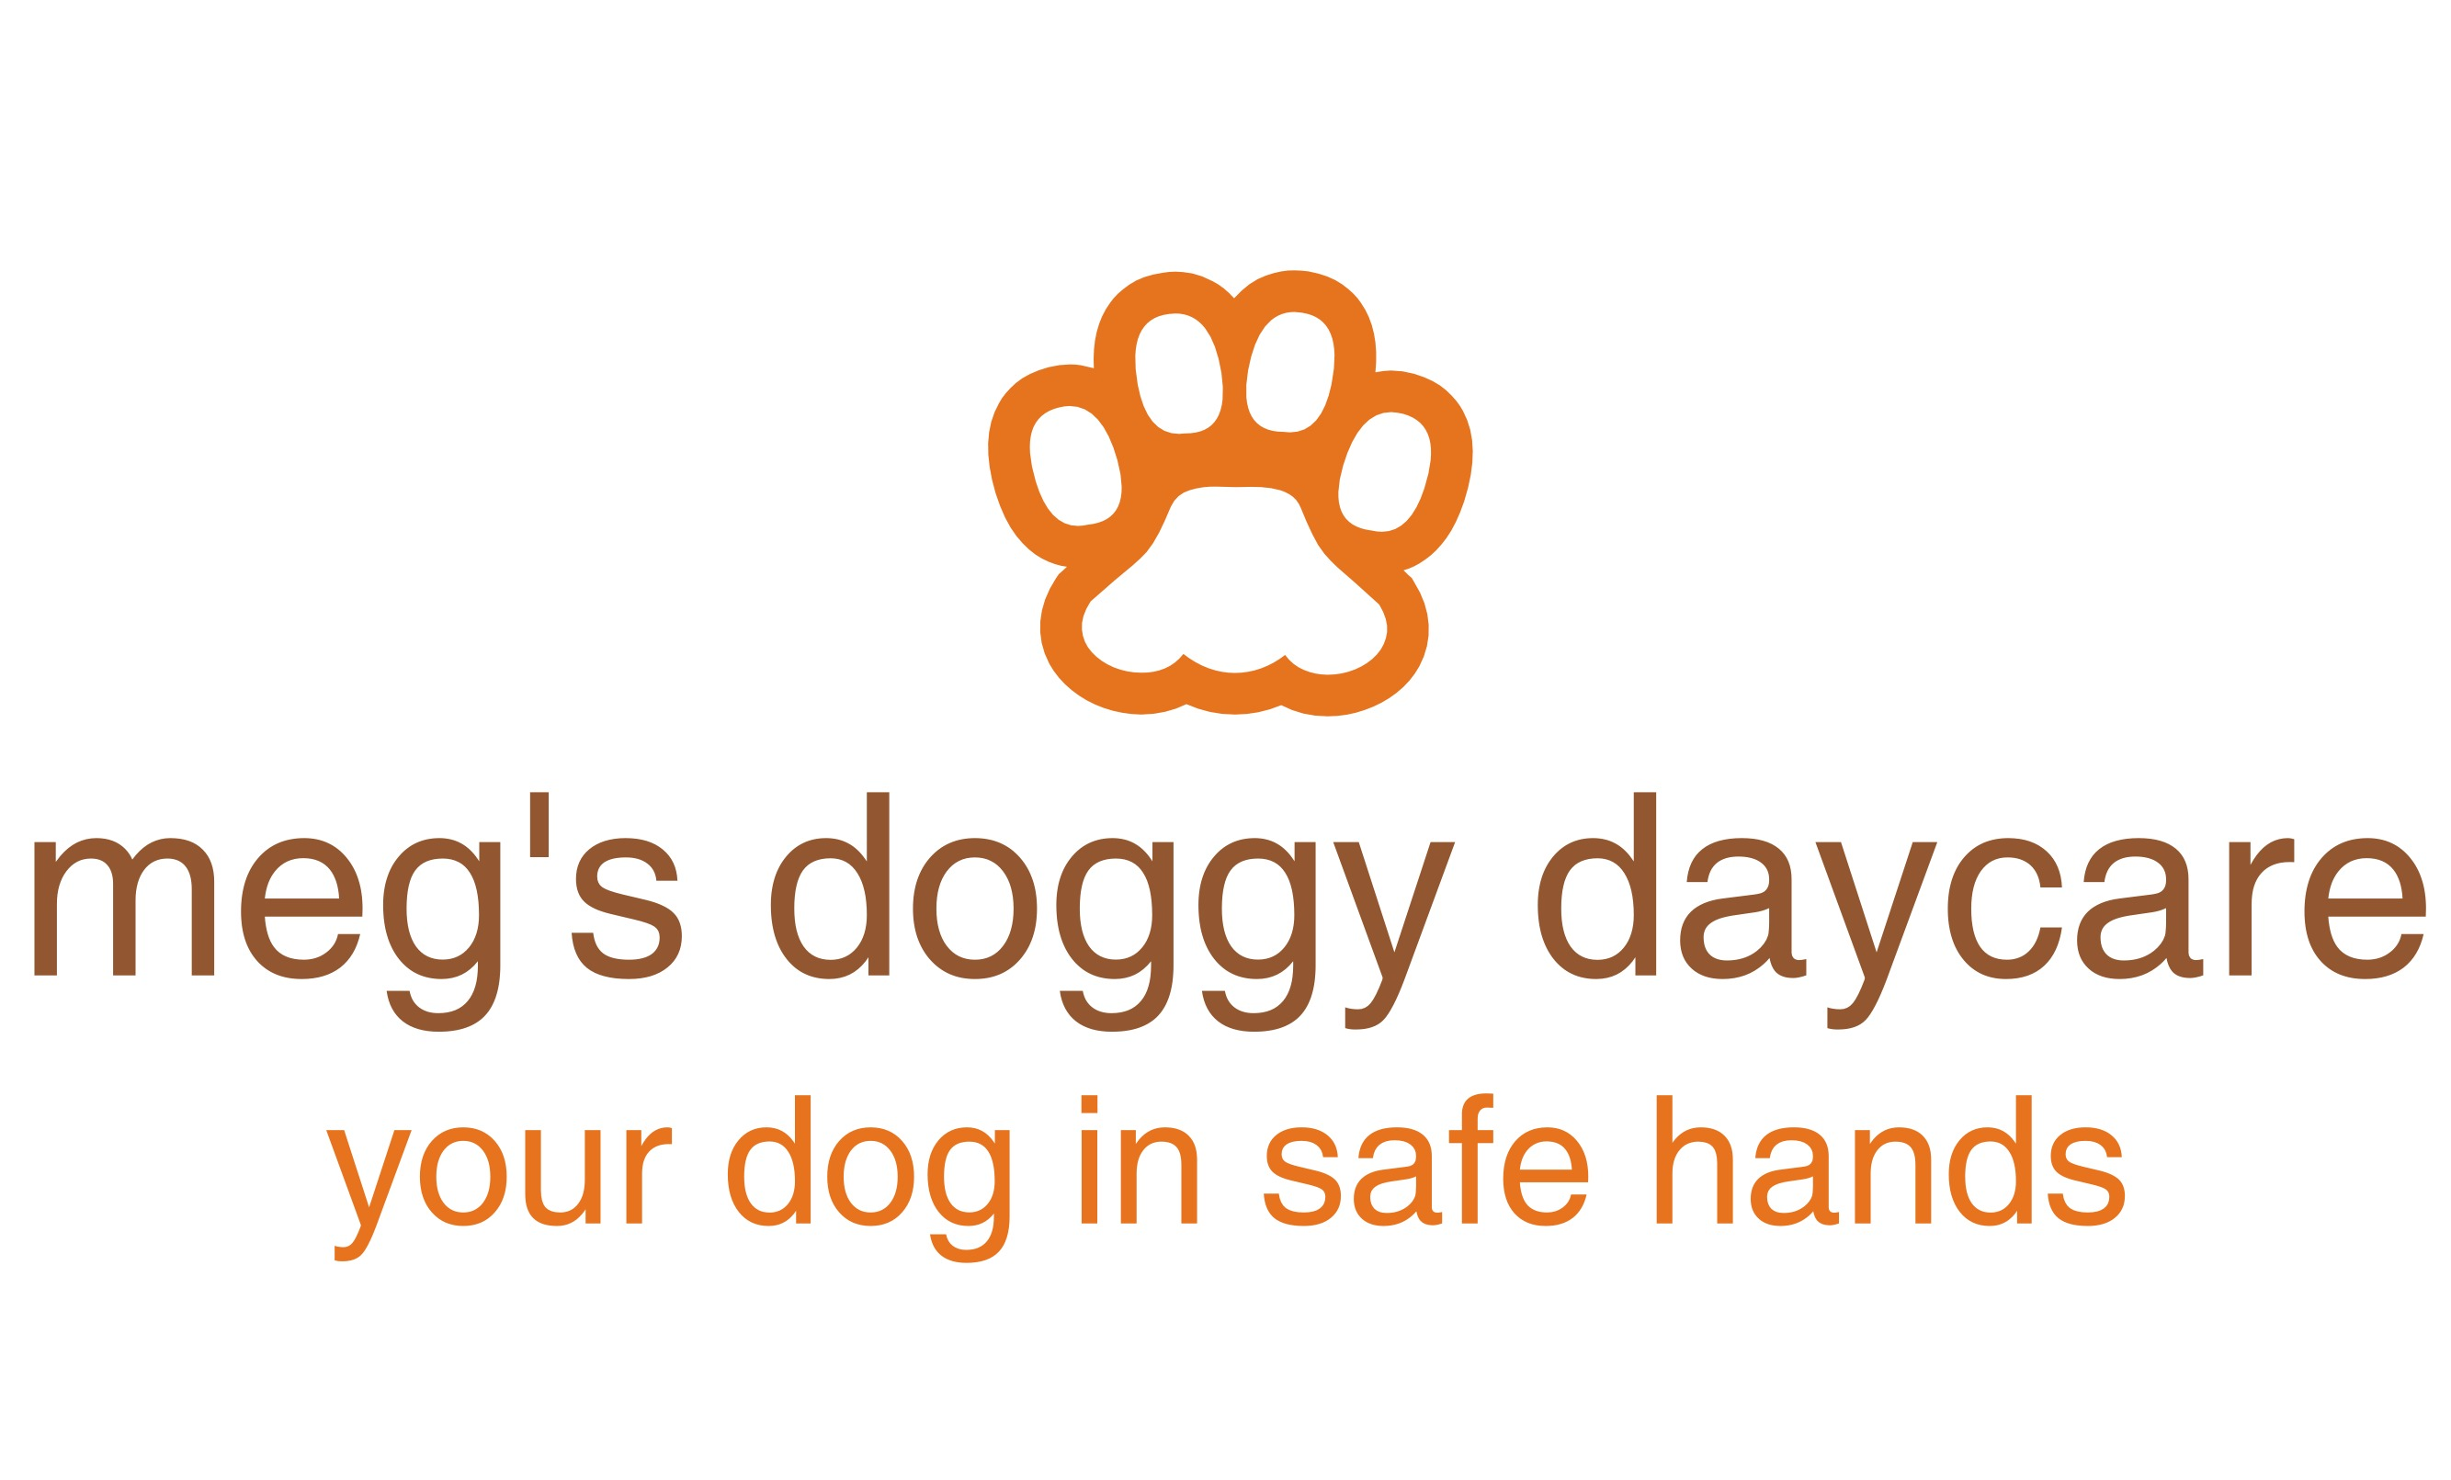

Off-Lead Walking Permission Form

I, …………………………................................................, give Meg’s Doggy Daycare permission to walk my dog, (name)………………………………………………………………. off it’s lead during any walk undertaken during my absence.
I understand the potential consequences that may occur to my dog or to other dogs if walking my dog off the lead while in the care of Meg’s Doggy Daycare.
I agree to release Meg’s Doggy Daycare from all liability including its members, agents, managers, and employees should my dog become lost, injured or otherwise harmed which may result in my dog being walked off the lead.
Meg’s Doggy Daycare agrees to exercise all reasonable and due care to prevent injury or death to my dog off the lead. However, in the event of injury/death, except those caused by reckless acts on the part of Meg’s Doggy Daycare, Meg’s Doggy Daycare will not be held liable for such injury/death of my dog as a result of off-lead walking.
I freely and voluntarily enter into this contract of permission with Meg’s Doggy Daycare and fully understand the above conditions.
This permission can be part of the Service Agreement but cannot replace the Service Agreement in part or in full.
I have read the Service Agreement, in particular paragraph 8.7. Copy of the Service Agreement is available on www.megsdoggydaycare.co.uk

Sign: ……………………………………………………………………………………………………………………….……

Full Name: ……………………………………………………………………………. Date: …………….….…………

meg’s doggy daycare, 62 cornwall road, cheam, sutton, surrey, sm2 6ds
mobile: 07552 936852 email: meg@megsdoggydaycare.co.uk
website: www.megsdoggydaycare.co.uk

